ESP32 Temperature and Humidity Monitoring System
Student Name: Thejaswini C Register Number: U03ZW24S0084 Class: B.Sc. 5th Semester MEC

- Project Title
ESP32 Based Temperature and Humidity Monitoring System using DHT22 and ThingSpeak
- Problem Statement
Monitoring temperature and humidity manually can be difficult and time-consuming. This project provides an IoT-based solution to measure temperature and humidity using a DHT22 sensor connected to an ESP32. The collected data is sent through Wi-Fi to the ThingSpeak cloud platform for monitoring and visualization.
- Objectives
To measure temperature and humidity using the DHT22 sensor. To interface the DHT22 sensor with ESP32.
To collect sensor readings using MicroPython.
To send the collected data to ThingSpeak through Wi-Fi.
To visualize temperature and humidity readings using graphs.
To understand the basic working of an IoT cloud-based monitoring system.
- Components and Software Used

Hardware:
ESP32
DHT22 Temperature and Humidity Sensor
Software/Platforms Wokwi Simulator MicroPython
ThingSpeak Cloud Platform

GitHub
- Circuit Diagram Connections

DHT22 Pin | ESP32 Pin | Connection
VCC | 3V3 | Power
DATA | GPIO 15 | Data
GND | GND | Ground

The circuit diagram showing the connections between the ESP32 and DHT22 Sensor is shown below:
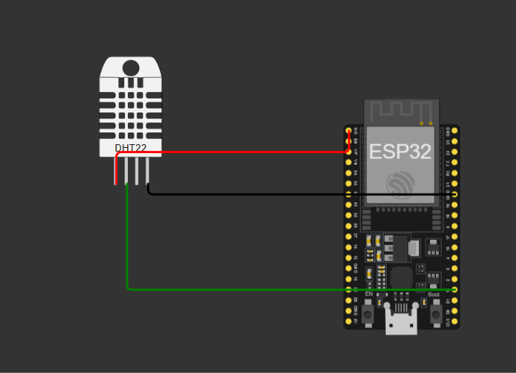

- Block Diagram:
The block diagram of the proposed IoT-based temperature and humidity monitoring system is shown below.

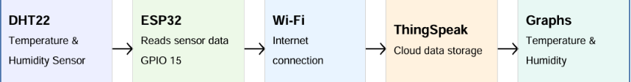

- Working Principle
The DHT22 sensor measures the surrounding temperature and humidity. The sensor is connected to GPIO 15 of the ESP32.
The ESP32 reads the sensor values using a MicroPython program. It then connects to the Internet through Wi-Fi and sends the temperature and humidity data to the ThingSpeak cloud platform.
ThingSpeak receives the data and displays it in the form of graphs. This allows the sensor readings to be monitored and visualized easily.
- Program Code import dht import time import network import urequests
from machine import Pin sensor = dht.DHT22(Pin(15))
wifi = network.WLAN(network.STA_IF) wifi.active(True)
wifi.connect("Wokwi-GUEST", "") print("Connecting to Wi-Fi...") while not wifi.isconnected():
time.sleep(1)
print("Wi-Fi connected!")
API_KEY = "YOUR_WRITE_API_KEY"
while True: sensor.measure()
temperature = sensor.temperature() humidity = sensor.humidity() print("Temperature:", temperature, "C") print("Humidity:", humidity, "%")

url = "https://api.thingspeak.com/update?api_key=" + API_KEY url = url + "&field1=" + str(temperature)
url = url + "&field2=" + str(humidity) response = urequests.get(url) print("ThingSpeak response:", response.text) time.sleep(15)
Program Explaination-
The program uses MicroPython to control the ESP32 and DHT22 sensor. Important parts of the program include:
import dht – imports the DHT sensor library.
from machine import Pin – allows the ESP32 GPIO pin to be used.
dht.DHT22(Pin(15)) – connects the DHT22 data pin to GPIO 15.
sensor.measure() – takes a new measurement.
sensor.temperature() – obtains the temperature value.
sensor.humidity() – obtains the humidity value.
Wi-Fi and HTTP requests are used to send the readings to ThingSpeak.
- Output
The ESP32 successfully reads temperature and humidity values from the DHT22 sensor.
The readings are displayed in the Wokwi serial monitor and are also sent to ThingSpeak. ThingSpeak displays the received temperature and humidity values using graphs.
Wokwi output screenshot
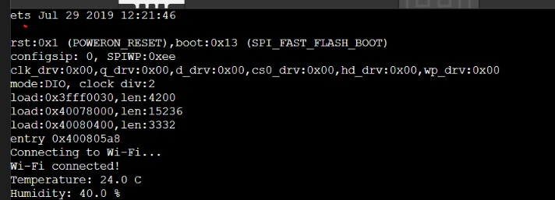

ThingSpeak graph screenshot

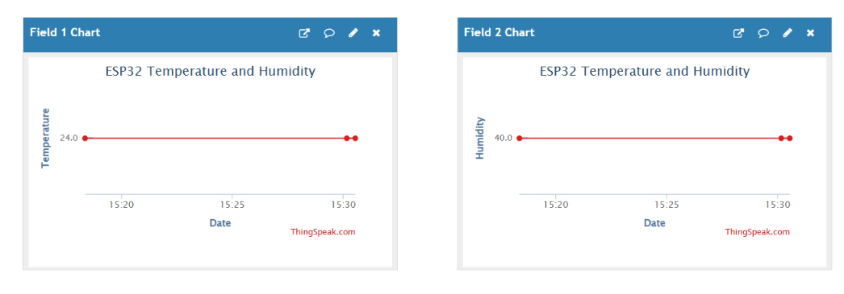

- Applications
Smart home environmental monitoring Agriculture and greenhouse monitoring Weather monitoring
Indoor temperature and humidity monitoring IoT-based environmental monitoring Educational IoT projects
- Limitations
The system requires Wi-Fi connectivity for cloud communication. DHT22 has limitations in measurement range and accuracy.
ThingSpeak requires Internet connectivity to receive and display data. Sensor readings may vary depending on environmental conditions.
- Future Scope
The project can be improved by:
Adding more sensors.
Adding mobile notifications and alerts. Using a mobile application for monitoring.
Adding automatic control based on temperature or humidity. Storing and analyzing larger amounts of sensor data.
Developing a complete smart-home monitoring system.

- Team Members' Details

NAMES | REGISTER NUMBER
Keerthi A | U03ZW24S0097
Sreethan H D | U03ZW24S0017
Jewel Mary Jibi | U03ZW24S0014

- Wokwi Project Link Wokwi Project: https://wokwi.com/projects/475682178620641281

ThingSpeak Channel Link
ThingSpeak Channel ID: 3500612
https://thingspeak.mathworks.com/channels/3500612/private_show

- Learning Reflection
Through this project, I learned how an IoT system can collect real-time environmental data using sensors and send the data to a cloud platform. I learned how to connect a DHT22 sensor with an ESP32, write a MicroPython program, simulate the circuit using Wokwi, connect the system to Wi-Fi, and send sensor readings to ThingSpeak. I also gained experience in using GitHub to store and present the project files. This project helped me understand the practical working of sensors, microcontrollers, cloud platforms, and IoT communication.
Conclusion
This project successfully demonstrates an IoT-based temperature and humidity monitoring system using ESP32 and DHT22. The sensor data is collected, sent through Wi-Fi to ThingSpeak, and displayed as graphs. Through this project, we gained practical knowledge of IoT, sensors, ESP32, MicroPython, cloud platforms, and Wokwi simulation.

